1. 
2. To understand TreeSet or TreeMap, we need to understand **Red-Black Tree.**But to understand **Red-Black Tree**, we need to understand **Binary Search Tree**.
3. 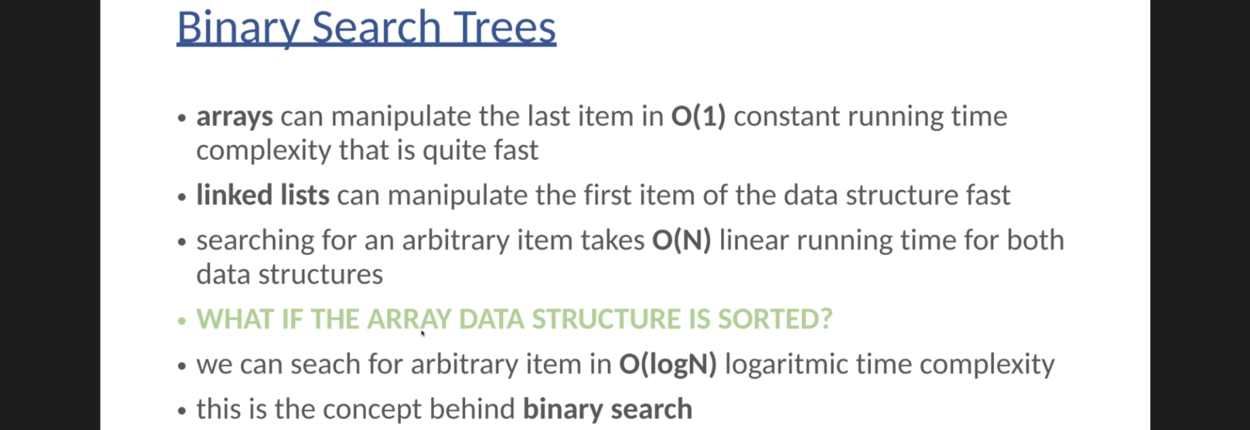
4. 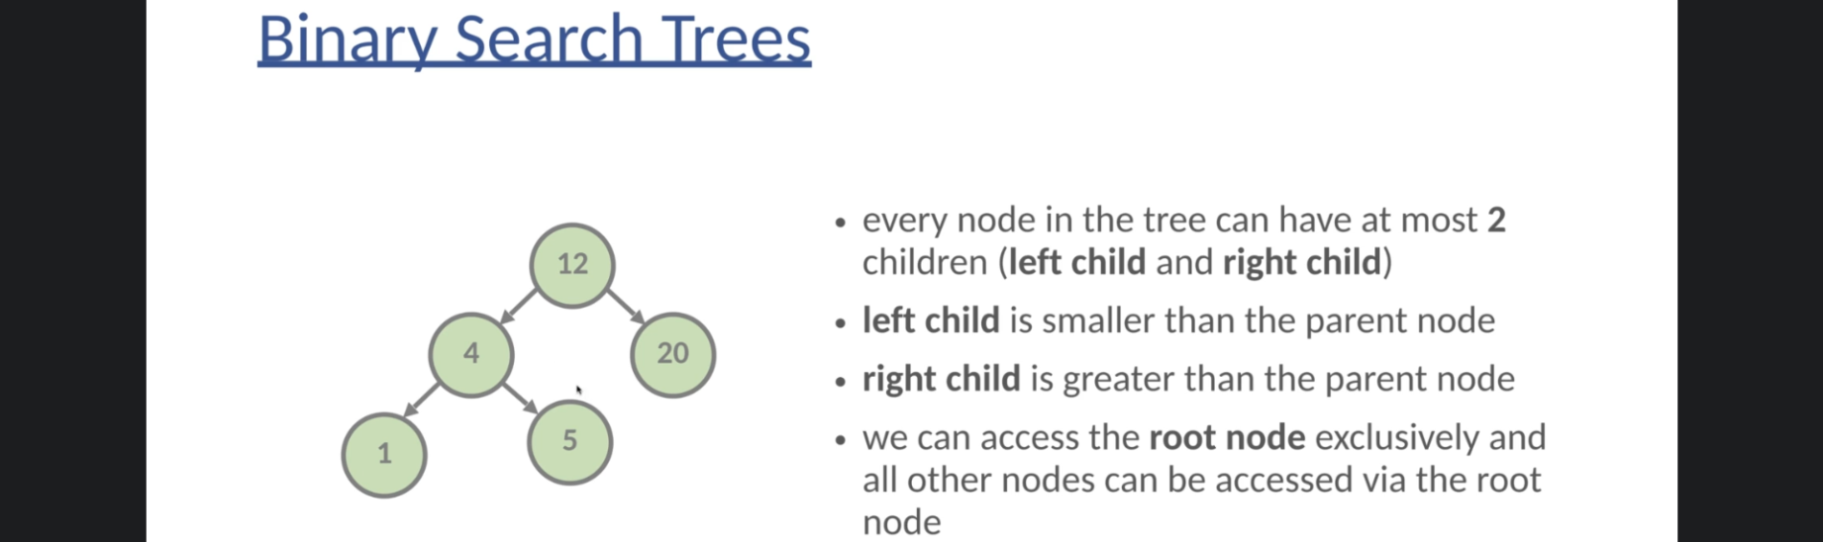
5. 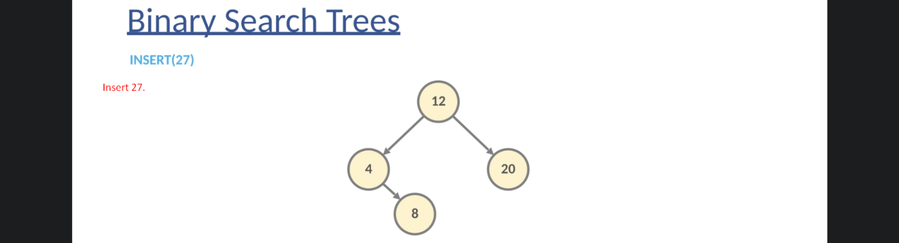
6. 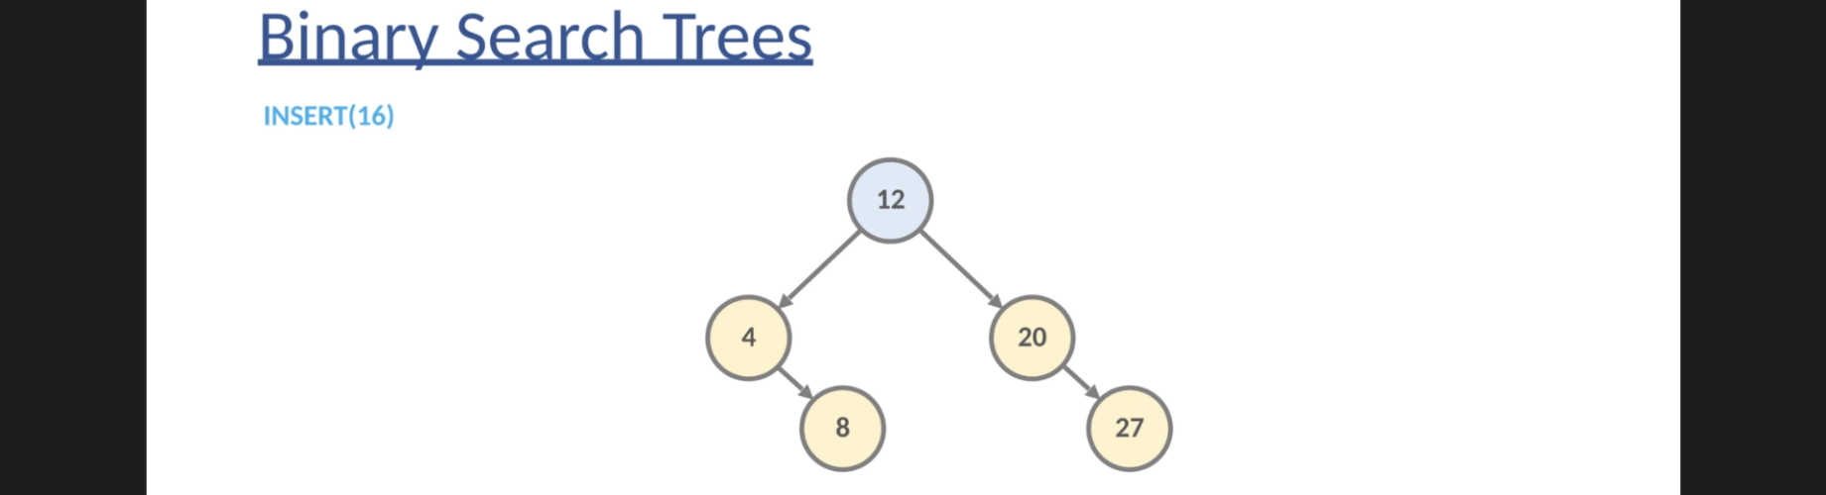
7. 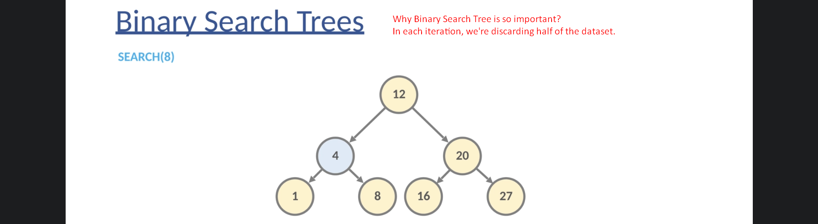
8. 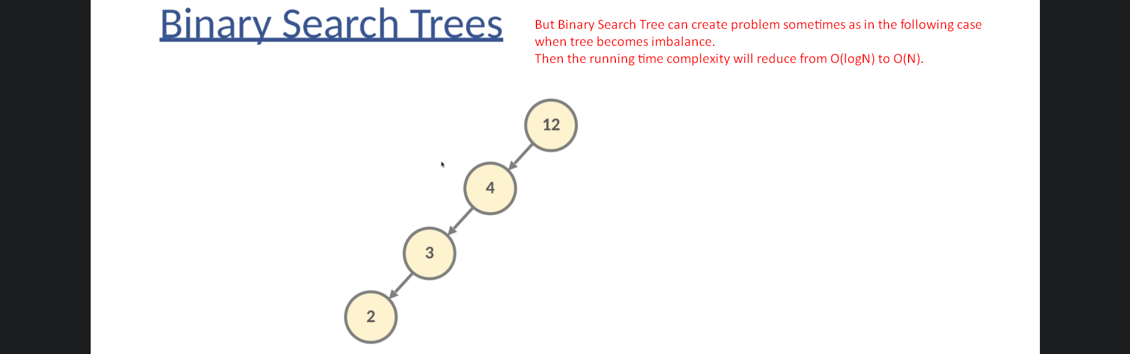
9. NOTE: In the above case, we ended up in the LinkedList.
10. **Solution**: Balance Binary Search Tree.
    1. **Two Kinds**
       1. AVS.
       2. Red-Black Tree: Java heavily relies on this.
11. **Red-Black Trees**:  
    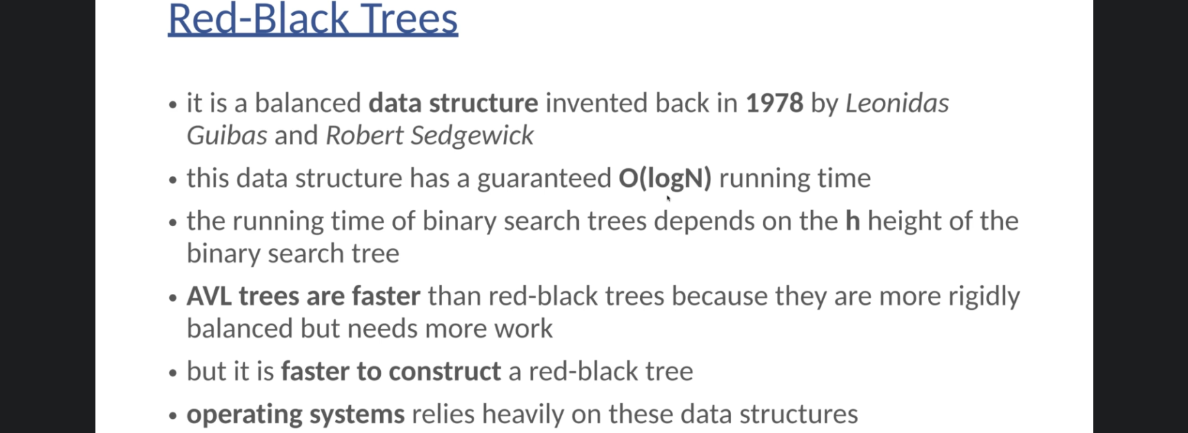
    1. This is concrete Data Structure behind TreeMap, TreeSet.
    2. This is balanced Binary Search Tree so guarantees O(logN) running time complexity. No matter it is average or worst scenario.  
       
    3. 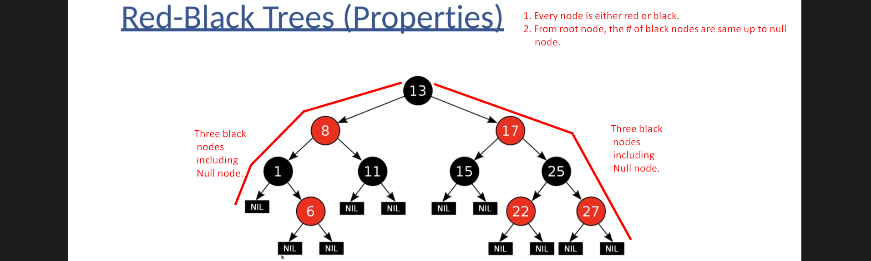
    4. 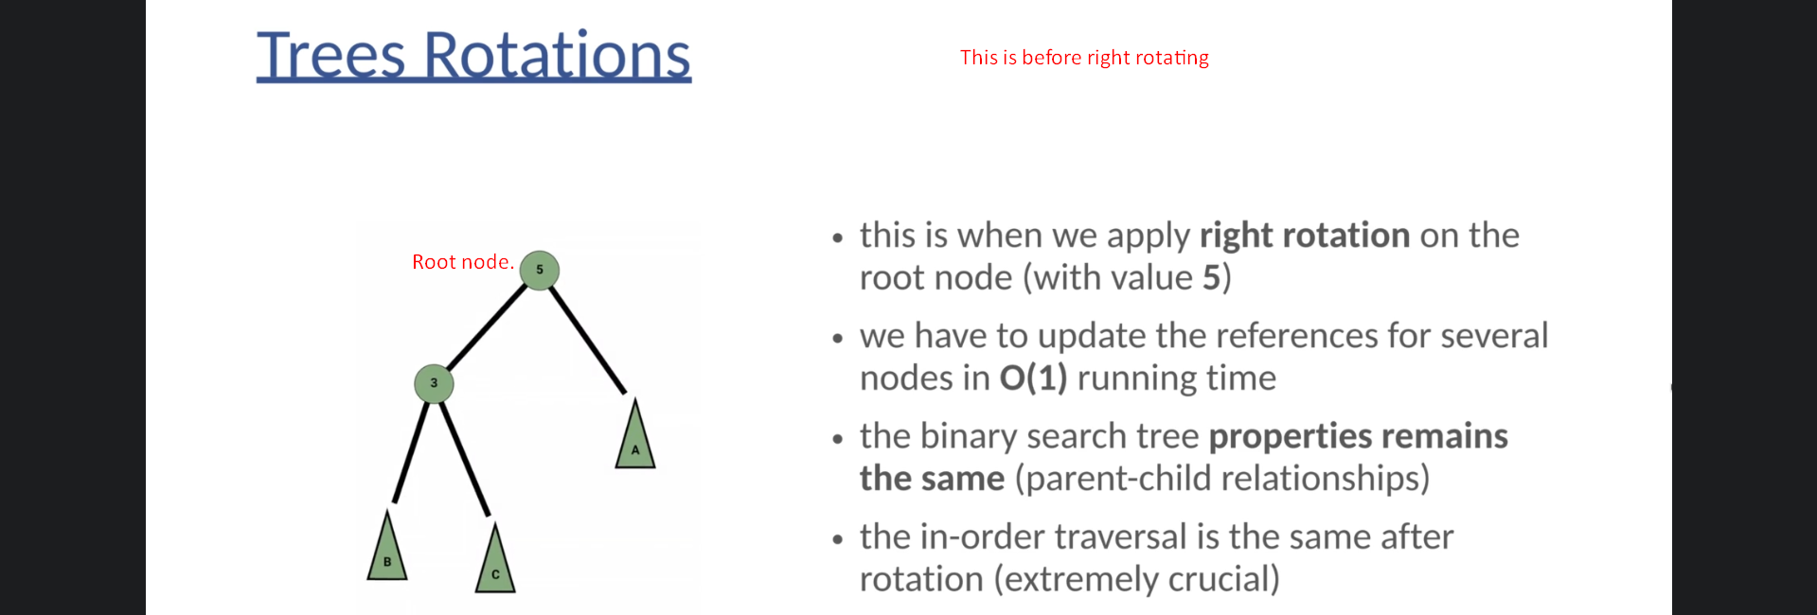
    5. 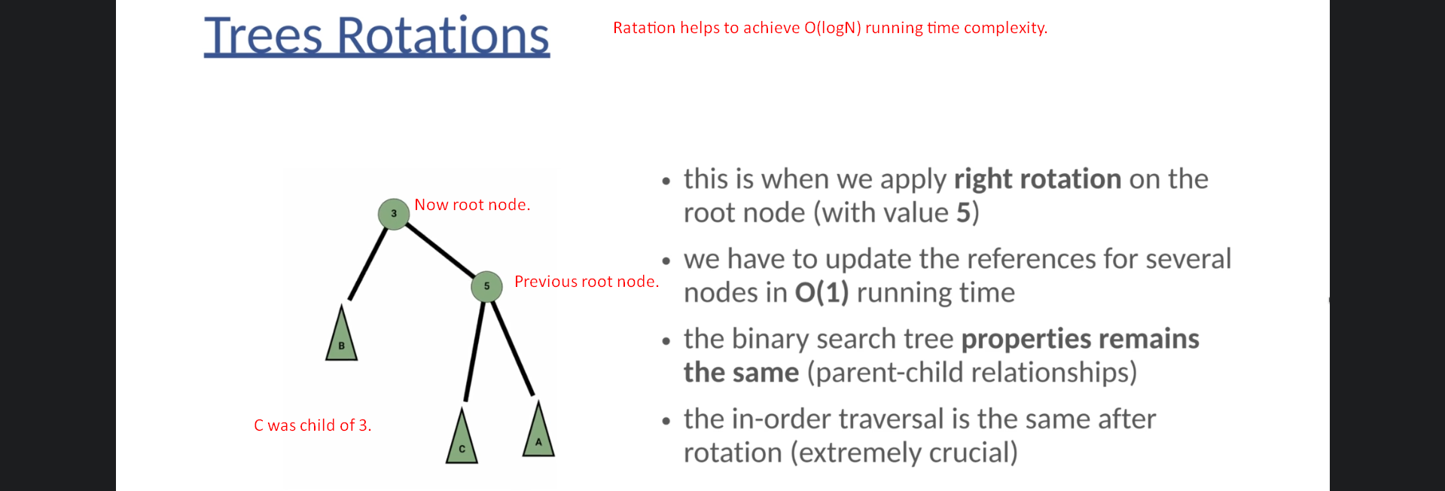
    6. 